**VIYYAPU PHALGUNA RAO-PROFILE**

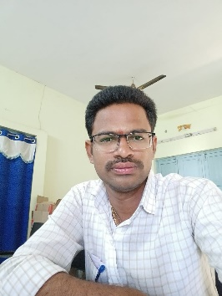

**NAME**: VIYYAPU PHALGUNA RAO

**Designation**   **:** Lecturer in Commerce

Govt. Degree College

PALAKONDA

Andhra Pradesh, India

E-Mail: gunanaidu.viyyapu@gmail.com

Mob: 9398692091

**Date of Birth :** 10/06/1992

**Qualification :** M.COM

**Date of Joining**  : 08/09/2014

**Prior to Govt. Service**  : 9 years

**Address (Res) :** GOVINDA RAO,D.NO:3-12,viyyapuvariveedhi,

lakkupuram village and

post,burju madalam,skml,AP-532445

|  |  |  |  |  |
| --- | --- | --- | --- | --- |
| **Qualification** | **University/Board** | **Year of Passing** | **% of marks** | **Class Secured** |
| **M.COM** | Andhra university | 2014 | 8.69 | **1st.** |
| **B.COM** | Andhra university | 2012 | 6.31 | **1st.** |

**Specialization: ACCOUNTING AND TAXATION**

**Teaching Experience:** 9years for UG

**TRAINING PROGRAMMES**

|  |  |  |  |
| --- | --- | --- | --- |
| **DATE** | **NAME OF THE TRAINING** | **ORGANISED** | **TOPIC** |
| 03/08/2022 TO 07/08/2022 | TOT (5 days) | APCCE | LOGISTICS AND SUPPLY CHAIN MANAGEMENT |
| 02/11/2022 TO 06/11/2022 | TOT (5 days) | APPCCE | RETAILING |
| 23/01/2023 TO 25/01/2023 | TOT (3 days) | APCCE | INTERNSHIP AND LMS |
| 05/06/2023 to 10/06/2023 | TOT (3 days) | APCCE | EMI |